273/2

Geography

Paper 2

2 ½

**ST JOHN’S HIGH SCHOOL KAWEMPE**

***Uganda Certificate for Lower Secondary Education {UCLSE}***

**S.2– GEOGRAPHY PAPER**

PAPER 2

TIME: 2 HOURS 30 MINUTES

***Instructions***

* Answer TWO questions only
* Any additional question(s) answered will not be marked

**PART I: The Rest of Africa.**

**Answer two questions from this part.**

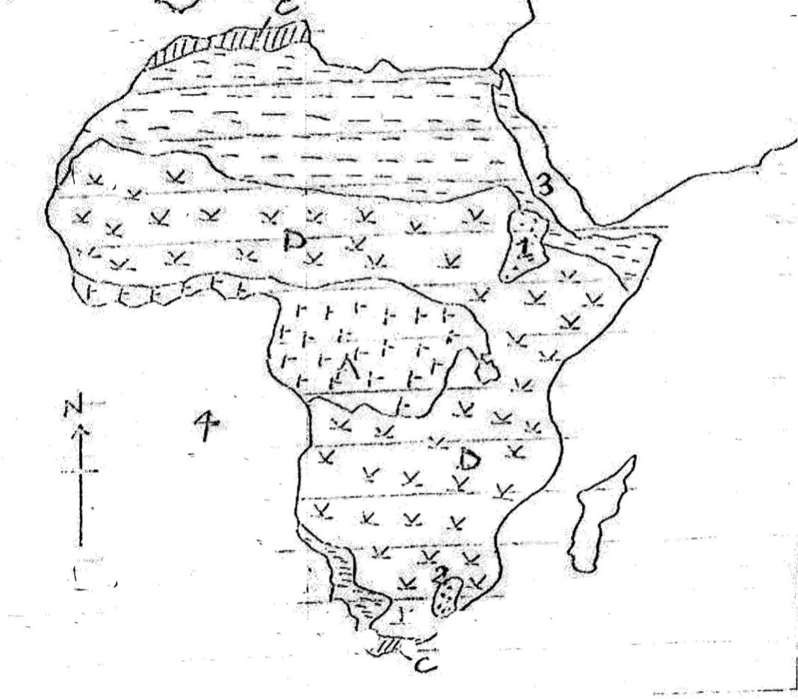

**A**

1.

1. Name the;
2. Vegetation types marked A,B,C and d,
3. Highlands marked 1 and 2,
4. Water bodies marked 3 and 4 (08 marks)
5. Describe the characteristics of the natural vegetation marked D. (6 marks)
6. Explain the conditions which have influenced the distribution of natural vegetation in Africa.

(7 marks)

1. Outline the influence of human activities on vegetation in Africa. (4 marks)

2. Study Fig. 1: Map of Africa provided and answer the questions that follow: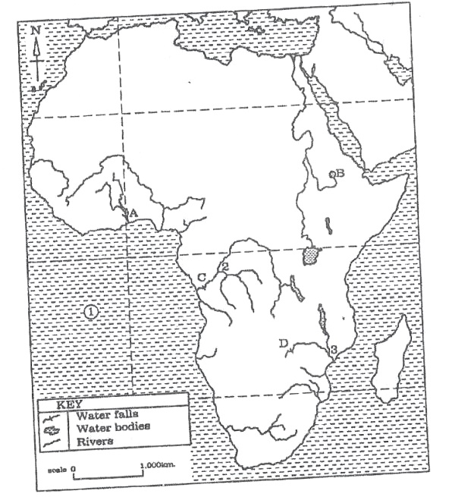

a)Name the:

i) Lakes marked A and B.

ii) Ocean marked 1.

iii) Rivers marked 2 and 3.

iv) Water falls marked C and D (07marks)

b) Describe the processes which led to the formation of any one waterfall named

in (a) (iv) above. (06marks)

c) Explain the benefits of the water fall chosen in (b) above to the people living in

the area. (08marks)

d) Outline the challenges facing the people living near rivers in Africa. (04marks)

3. Study table I. below showing climate of station A and answer the questions that

follow:

**TABLE I CLIMATE OF STATION A**

|  |  |  |  |  |  |  |  |  |  |  |  |  |
| --- | --- | --- | --- | --- | --- | --- | --- | --- | --- | --- | --- | --- |
| Months | J | F | M | A | M | J | J | A | S | O | N | D |
| Temp (0C) | 30 | 31 | 31 | 30 | 29 | 28 | 28 | 28 | 28 | 29 | 30 | 30 |
| R/F (mm) | 25 | 25 | 50 | 100 | 275 | 500 | 900 | 925 | 700 | 300 | 125 | 25 |

Source: W.J. Means: A Geography of Africa Pg 37.

a) Draw a suitable graph to show the climate of station A. (09marks)

b) Calculate the:

i) mean annual rainfall of station A.

ii) Annual range of temperature for station A. (04marks)

c) Describe the climate of station A. (06marks)

d) i) State the Hemisphere in which station A is located. (01mark )

ii) Outline the economic activities that can be carried out around station A.

(05marks)